attachment 92 (part A)
Hazard Identification, Risk Assessment and Corrective Action Form

Hazard Identification, Risk Assessment and Corrective Action Form
Step 1A. Hazard identification – completed by employee or employer
If urgent please ring or contact employer immediately, control situation as best you can without exposing yourself or others to undue harm. Then follow up as soon as possible with completion of this form.
Date: ………………………….. Hazard raised by (please print name): ………………………………………………
Please describe possible workplace hazard in as much detail as possible including where it is located,
source if known, who might be exposed to harm, how long it’s been around, if there are precautions that
are already in place, if you think there are problems with these existing precautions, and any ideas you
have on more effective precautions.
………………………………………………………………………………………………………………………………
………………………………………………………………………………………………………………………………
………………………………………………………………………………………………………………………………
Step 1B. Hazard notification – completed by employee and employer
This form forwarded to management or employer representative on [insert date]: ………………………………….
Name of employer representative: ……………………………………………………………………………………….
Signature of employer representative: …………………………………………………………………………………...
Step 1C. Hazard analysis – completed by employer in consultation with employee(s)
Cross-reference to other documents and date: …………………………………………………………………………
Other information reviewed and assistance received: ………………………………………………………………….
………………………………………………………………………………………………………………………………
………………………………………………………………………………………………………………………………
Hazard/item/task to be assessed: ……………………………………………… Date: ……………………………….
Location(s) of hazard/item/task: …………………………………………………………………………………………..
Possible reasons for presence of hazard and identify hazard source if known or suspected:
………………………………………………………………………………………………………………………………
………………………………………………………………………………………………………………………………
Step 2. Risk assessment – completed by employer in consultation with employee(s)
Use the spreadsheet table in this form. To help determine the Risk Level (if required) please use this Risk Assessment Tool, or other tool as agreed by the employer team.
When you use the matrix, try not to be too concerned about the need to always get the ‘correct’ risk
level. Whether the risk is precisely ‘high’, ‘medium’ or ‘low’ is only an approximate indication of real situations involved and the tool is intended to provide a useful guide in deciding priorities in controlling the risk.
Risk level = likelihood x consequence
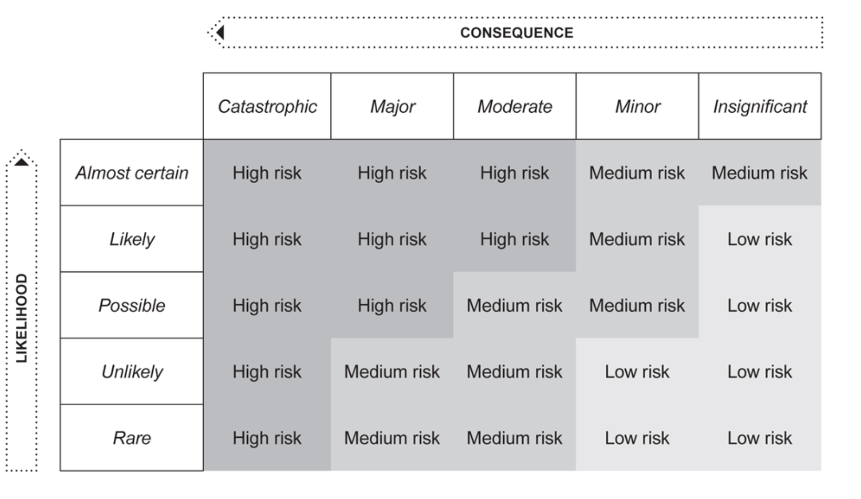
Likelihood
Almost certain: we can be sure it will happen
Likely: good chance it will happen
Possible: perhaps it will happen sometime
Unlikely: could happen but it would be unusual
Rare: could happen but probably never will
Consequence
Catastrophic: person is killed or totally disabled
Major: very serious injury or long-term illness
Moderate: quite serious injury/illness involving some days off work
Minor: some first aid or minor medical attention, but no lost time
Insignificant: some discomfort, but no medical attention needed
Step 3. Determine corrective action (risk control measures) required –
completed by employer in consultation with employee(s)
Use the spreadsheet table in this form. To help determine possible risk control measures you need to consider:
• Ensuring your OHS issue resolution procedure is being followed,
• What risk controls are in place and are these working effectively,
• If these are not effective analyse why not,
• Determine relevant best practice by looking at guidance in the Early Childhood Management Manual
OHS Section 9, WorkSafe Victoria website www.worksafe.vic.gov.au (then select ‘Publications’ tab)
and the KPV website www.kpv.org.au,
• Seeking assistance from one or more of:
– WorkSafe Victoria hotline Tel: (03) 9641 1444
– KPV Tel: (03) 9489 3500
– Your Worker’s Compensation Insurer or Agent
– An OHS Consultant
– Employee representative organisations such as Trade Unions (note that Trades Hall Council has
a possibly useful website http://www.vthc.org.au.
• Ensuring you consider the possibility of alternation to risk levels, or introduction of new hazards
and risks due to proposed changes including corrective action and risk controls.
• Ensure you consider your recovery or emergency response measures are suitable for existing,
improved and new risk controls (i.e. consider are relevant persons including employees prepared
if these risk controls fail? And under what circumstances might these risk controls fail?).
If required, record details of other information reviewed and assistance received:
Step 4. Monitor and review effectiveness of risk controls and changes made – completed by
employer in consultation with employee(s)
Use the spreadsheet table in this form. Responsible persons need to be assigned, and they need to
agree to monitoring and reviewing the effectiveness of risk controls and any changes made. These
persons need to report their findings to other employer representatives. The employer representatives
then need to determine if the corrective action has been completed, instigate other action as needed,
and keep records on file.

